Setting up a Capital Contingency (Planned Savings) in FMS6

Link 3972 Contingency – Planned Savings to the Capital Fund i.e. Devolved Capital - Fund 02.

From Menu bar select Tools/General Ledger Set Up

Select tab 5 - Ledger Codes.

Find ledger code 3972

Double click on this ledger line

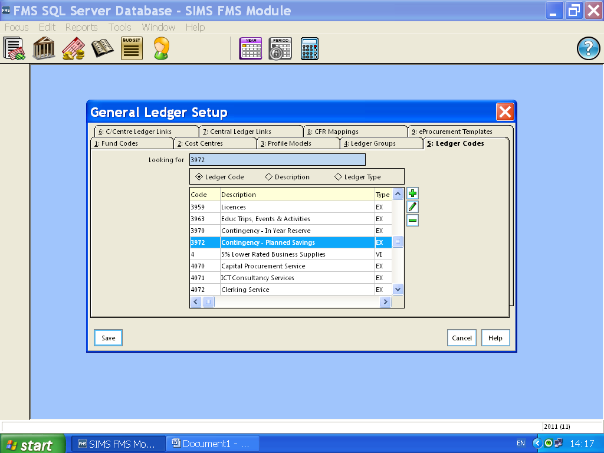Click onto spyglass at the right-hand side of Funds

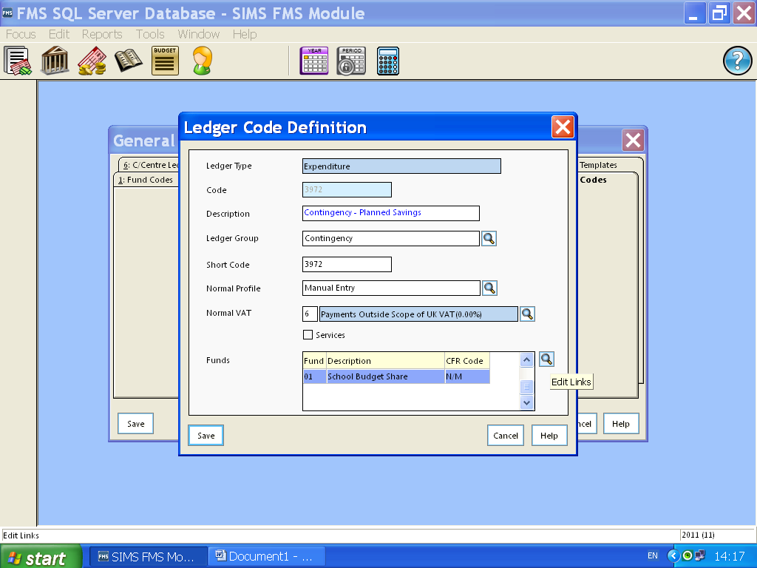

Choose Capital Fund Codes and move over to linked funds using arrow

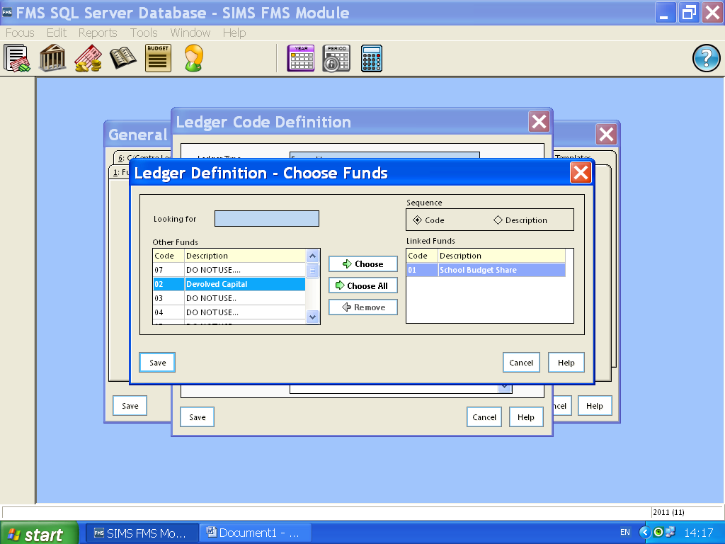

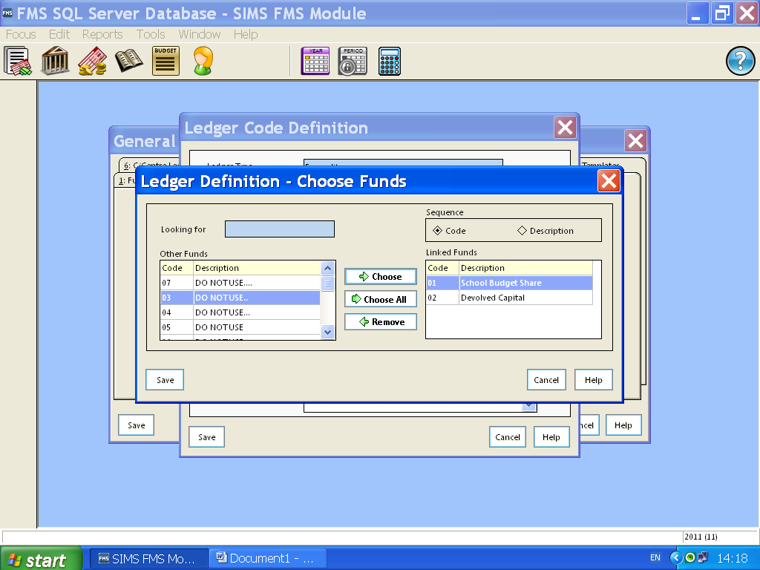

Save and save again
Set up Contingency – Planned Savings for each capital fund

From Menu bar select Tools/General Ledger Set Up

Select tab 2 – Cost Centres

Double click on yellow folder “Reserves”

Make sure you are on the yellow folder “Contingency – Planned Savings” add a new sub cost centre using the + note pad button below the + yellow folder button. You should use an appropriate number that falls in line with your other Contingency-Plan Savings cost centres i.e. RO2E and name it e.g. Contingency-Plan Savings DEV CAP.

Save

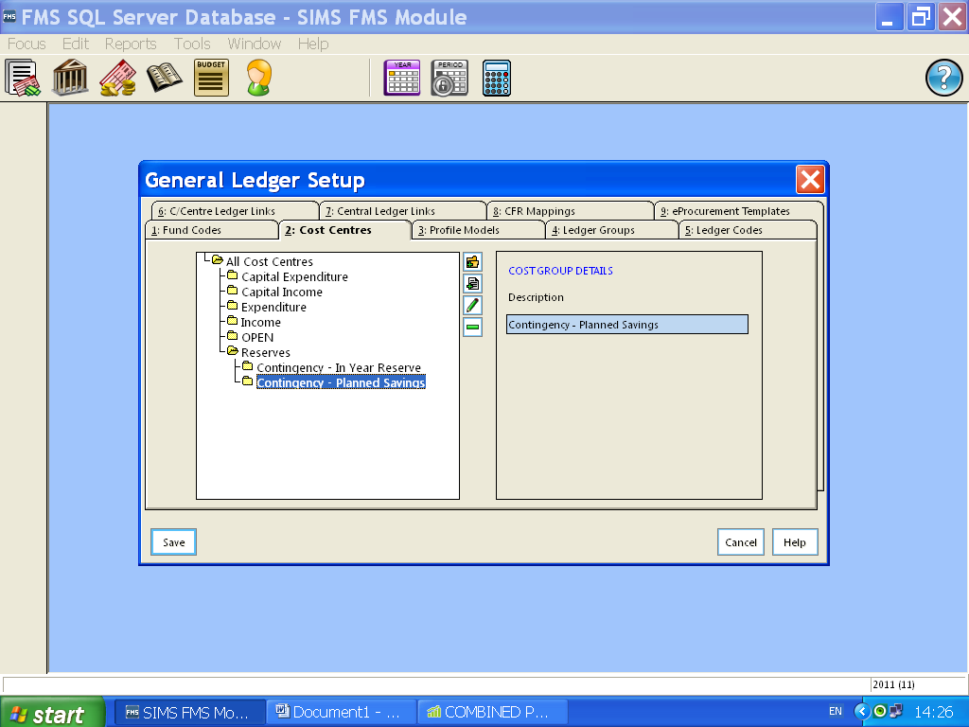Now we have linked 3972 Contingency – Planned Savings to the Capital Fund(s)

From Menu bar select Tools/General Ledger Set Up

Select tab 6 – C/Centres Ledger Links

Add using the + button

The next window will appear showing you available cost centres in top field and available ledger codes in the bottom field.

You should choose the New Contingency – Planned Savings Cost Centre and take it across to the right using the small arrow e.g. RO2E Contingency-Plan Savings DEV CAP.

Move to the second field and choose appropriate ledger code with the correct fund extension e.g. 3972-02 and take it across to the right using the small arrow.

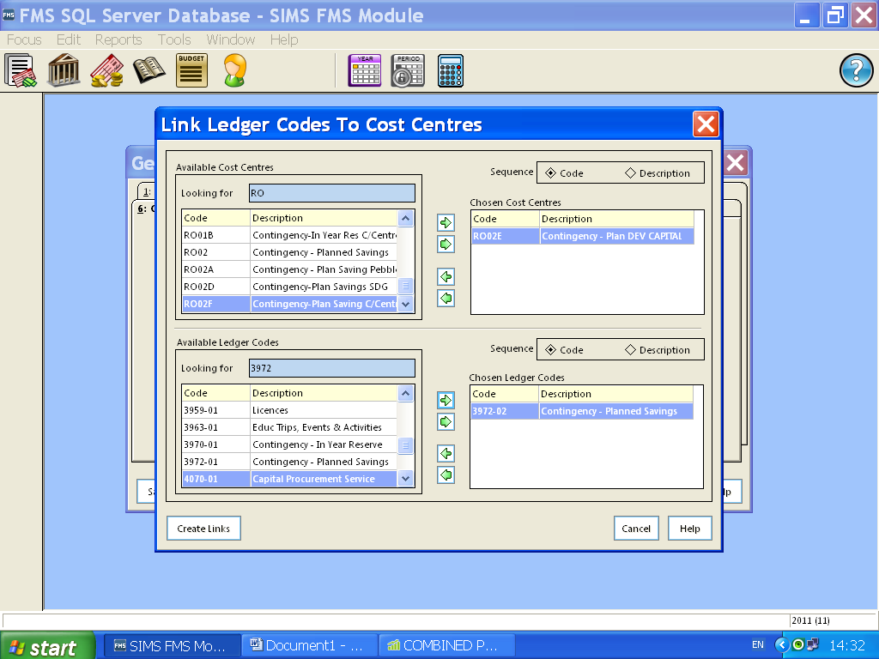

Select Create Links to Save

Repeat the above for additional Capital funds you wish to set up a Capital Contingency - Planned Savings for.

